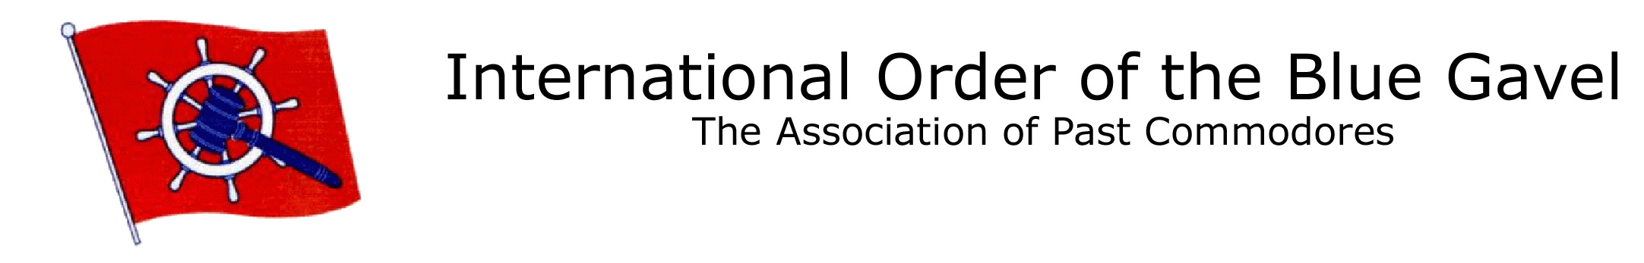

Date: (Highlight this sentence and type the date here)

Dear Past Commodore (Highlight this sentence and type the name here)

What a shame when our Past Commodores disappear from sight or no longer take an active/advisory role in their respective clubs after completing their term of office. You are the very people that we need to keep active in our clubs, offering experience and high-level views for the benefit of the club and the boating community in general.

We in Blue Gavel assist in District matters, local, national and international yachting community events.

The mission of the Blue Gavel organization is to recognize Past Commodores of the international yachting community and unite them in order to promote the highest ideals of yachting and preserve its customs and traditions through social, educational and humanitarian programs.

Our clubs can and should draw upon the huge pools of knowledge in our Past Commodores to supplement their resources. What a wonderful source of help in problem solving, dispute resolution and general mentoring. The Blue Gavel Past Commodores have welcomed the opportunity to continue being of service.

Enclosed you will find a brochure describing IOBG and the benefits of membership.

I would hope that after you read about Blue Gavel you would contact me to discuss membership for yourself and other Past Commodores of your club and region.

Thank you for your interest.

Sincerely Yours,

P/C (Highlight this sentence and type your name here)

Address:
(Highlight this sentence and type your address here)
(Highlight this sentence and type your address here)

Phone: (Highlight this sentence and type your phone number here)

Email: (Highlight this sentence and type your email address here)

